LOYOLA COLLEGE (AUTONOMOUS), CHENNAI – 600 034
B.A. DEGREE EXAMINATION – ENGLISH LITERATURE
FIFTH SEMESTER – NOVEMBER 2010
EL 5401 - INDIAN FOLKLORE

Date : 11-11-10 Dept. No. Max. : 100 Marks
Time : 9:00 - 12:00

I . Write short notes on any FIVE of the following oral genres (75 word each): 5 x 4 = 20
- Folklore
- Riddle
- A few Proverbs
- Folktale
- Kutiyattam in a global context
- Ballad
- Villupattu
- Kaavadi Aatam
II. Answer any FOUR of the following in not less than 200 words each: 4 x 10 = 40

- The Birth of a first child is a great event well celebrated by the kith and kin in any household. Justify this conception.
- India has been the birth place at several games that are popular to this day. State the names of the various games that are played.
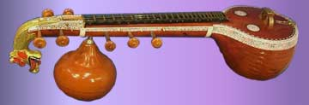

- The finest string instrument of India is the Veena.

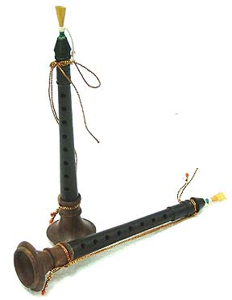

and Nadaswaram noted as an auspicious musical instrument. Bring out the specialty of these two instruments.

- Write the significance and relevance of Karagattam in temples and on festival occasions as entertainment.
- Silambaattam, Bommalaattam, Poikkal kudiraiaattam and Oyilaattam are directly connected with religious ceremonies. Briefly explain each of these dances.

III. Attempt an Essay on any TWO of the following in 300 – 350 words each: 2 x 20 = 40

- Fairs and Festivals are part of cultural, social, agricultural and recreational life. Discuss
- What are the various types of folk songs which are most common in Tamil Literature?
- Chennai Corporation has done a laudable work in setting up sculptures that depicts various folk forms and the walls of the city are painted signifying games and fests. How do you justify your visit around the city?

***************

